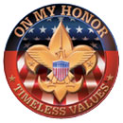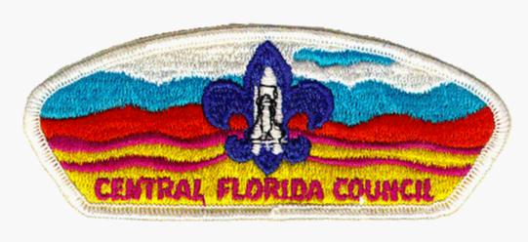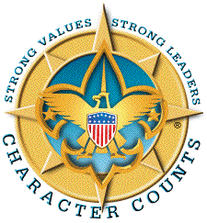

Friday, July 31, 2026
Joseph F. Belland
EAGLE SCOUT CANDIDATE
Boy Scouts of America
Troop 590 – Lake Helen, Florida
Friends of Scouting
Friends of American Legion Post 127 Lake Helen
Friends of Americans with Disabilities 

My Name is Joseph F. Belland; I’m an Eagle Scout Candidate with Boy Scout Troop 590, Lake Helen, Florida.
I have elected for an Eagle Scout Project, the Design, Management, and Installation of Handicap facilities for the American Legion Post 127 Hall located at 109 CASSADAGA RD, Lake Helen, Florida 32744-3244.
The much needed Handicap facilities are for a dual Handicap drive and access walk way to the hall. I have included a copy of my Eagle Project Concept plan for the Handicap facilities which includes: dual drive ways, walk ways from front door to rear doors connecting in front of the dual handicap concrete drive ways.
The American Legion Post 127 established in 1941 and the Hall was built in 1952 is used by many different Civic, Boy Scouts, Cub Scouts, and Volunteer groups from Lake Helen and other parts of Volusia County.
Below is the Concept Design plan:
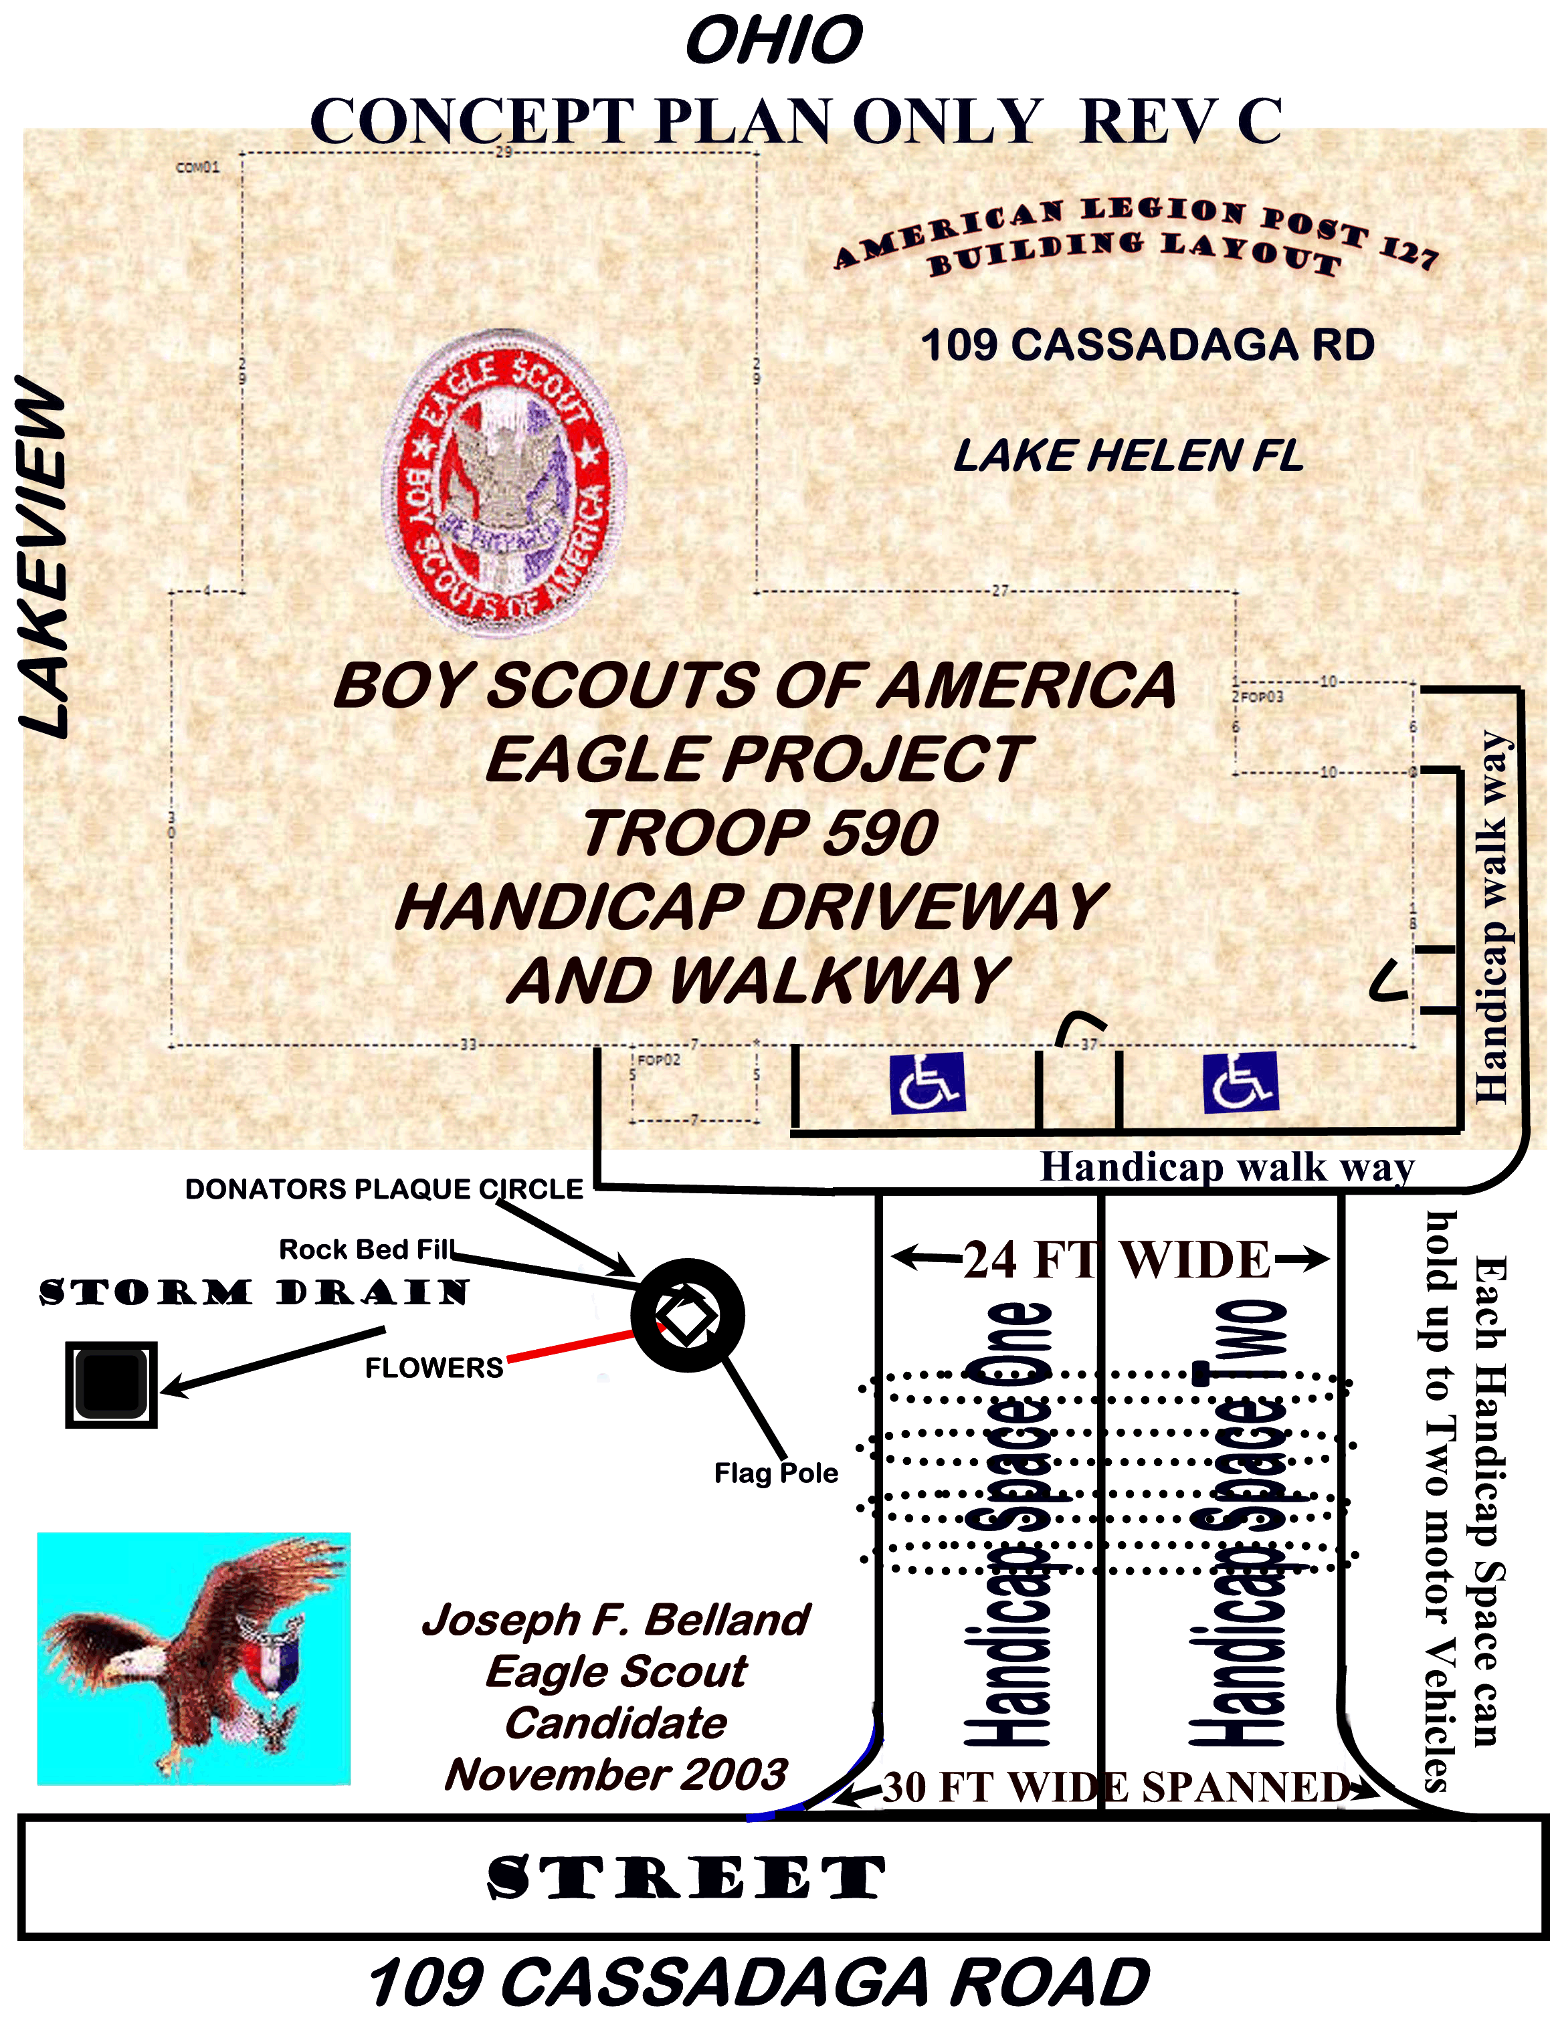
Friday, July 31, 2026
Funds raisers are currently underway to purchase the raw material that are needed to install the Handicap facilities An all Volunteer Labor force will perform the actual work. Volunteer Labor force, material donations, heavy equipment supporters can sign-up at the Eagle Scout Project Web Site located at:
http://WWW.BSATROOP590FL.ORG/troop590/JOE.F.BELLAND.EAGLE.PROJECT.htm
I need volunteer Labor and Financial support to help accomplish the Eagle Scout Project.
All fund raising, purchase of materials, volunteer work, and final construction (with pictures) that will be performed is required to be documented; and, will be available for Public inspection at the Eagle Scout Project Web Site located at: http://WWW.BSATROOP590FL.ORG/troop590/JOE.F.BELLAND.EAGLE.PROJECT.htm
The American Legion Post 127 Hall Phone Number is (386) 228-2770.
Paul Cartier is the American Legion Post 127 Commander His phone number is (386) 228-2515. My Scout Master is Jim Connell His phone number is (386) 436-4557. My Parents are Frank & Mary Jane Belland and our phone number is (386) 668-0359
The Eagle project is well underway; with an estimated completion date of Nov/Dec 2004; made possible only with your Donation support today to reach the funding goal of $4,000.00 to purchase materials.
Donations can be made using Credit Cards (American Express, VISA, MasterCard, and Discover), at the Eagle Project Web Site: http://WWW.BSATROOP590FL.ORG/troop590/JOE.F.BELLAND.EAGLE.PROJECT.htm
Make your Check or Money Order Donation Payable to:

Boy Scouts of America Troop 590 JFB Eagle Project Fund

Mail your donation to:

Joseph F. belland
Eagle Scout Candidate - American Legion Building Fund
C/O BSA Troop 590
Mrs. Cindy Shaw, Treasurer
Post Office Box 503
Lake Helen Florida 32744

Donation Checks and Money Orders can also be given to the American Legion Post 127 made
Payable to:
Boys Scouts of America Troop 590 JFB Eagle Project Fund

Joseph F. Belland can be reached at (386) 668-0359
All Donations receive a Letter of Donation for Tax purposes, from the American Legion Post 127 & Boy Scout Troop 590, Lake Helen Florida.
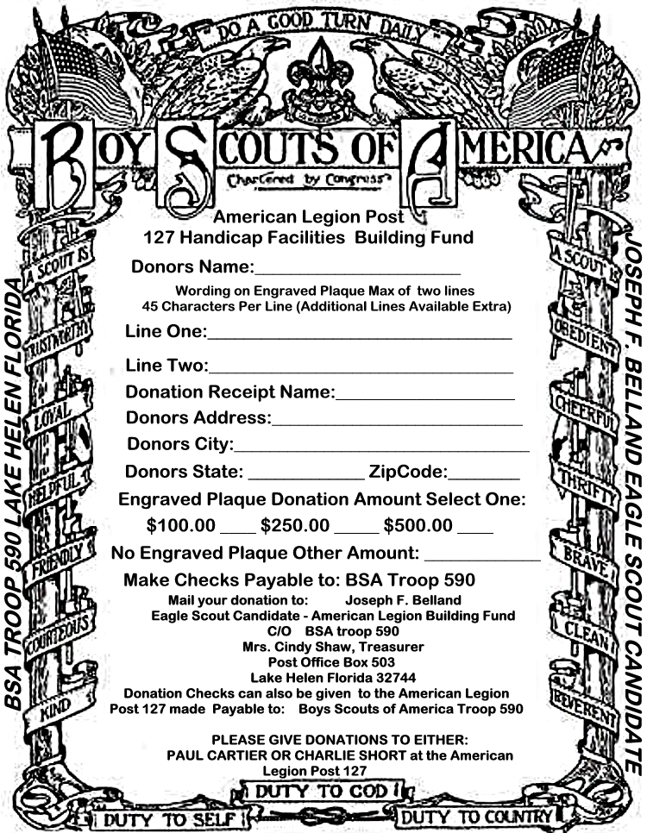
Friday, July 31, 2026

Below are Donators Plaques that will be implanted around the Walk way, Drive way and Entrance to Honor supporters of this American Legion Handicap Facilities Building fund:

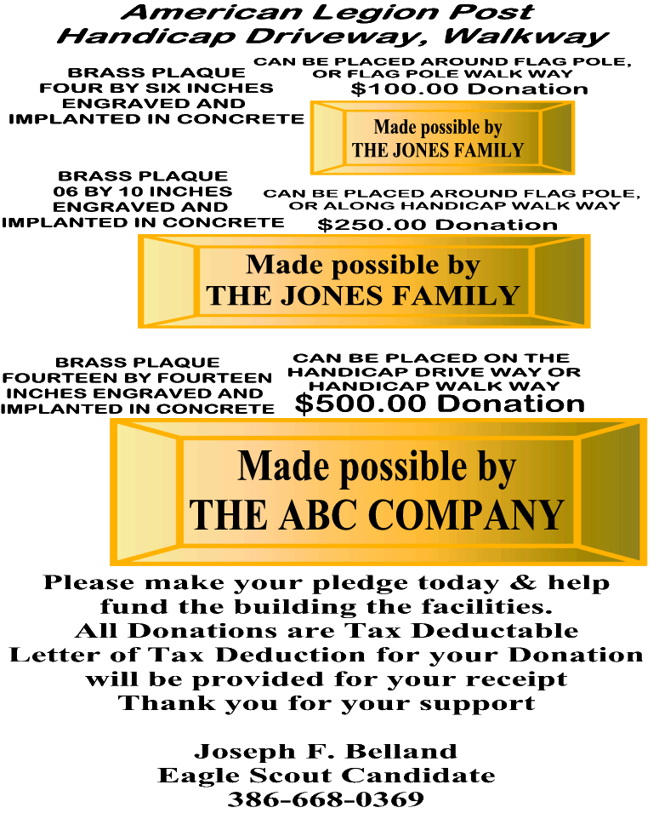

Friday, July 31, 2026
On March 4, 2004 in Lake Helen at the Commissioners monthly meeting I made a presentation to the Commissioners and received 100% backing on Building permits cost relief, Donation collection permits, and other permits required to build the Handicap Facilities. Below are picture of my presentation to the commissioners of Lake Helen:
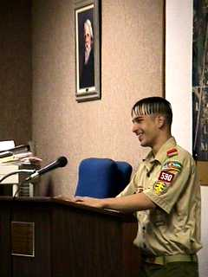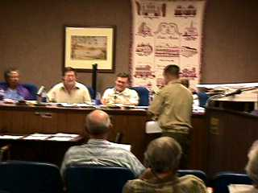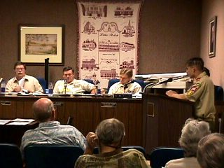
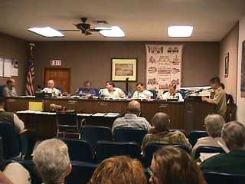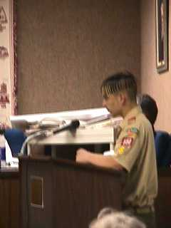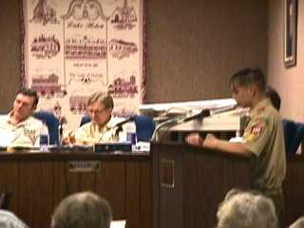
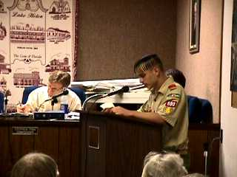
Friday, July 31, 2026

Full press coverage was in the DeLand-Deltona Beacon Newspaper the week after the March 4, 2004 presentation.

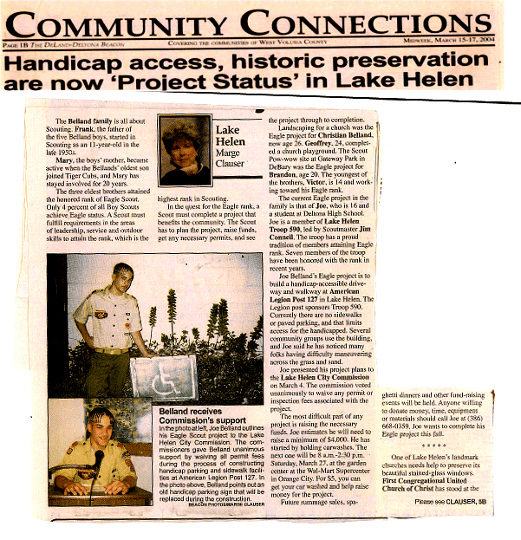
Friday, July 31, 2026

A PLEA FOR DONATIONS was in the DeLand-Deltona Beacon Newspaper the week after the May 25, 2004.
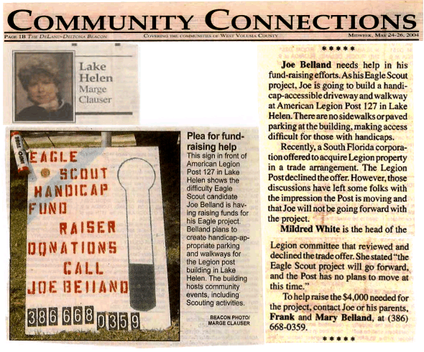
Again, thank you very much for any assistance and any Donation to complete this Boy Scout Eagle project.
Yours in Scouting,
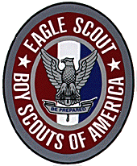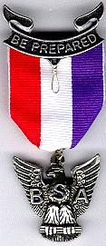
Joseph F. Belland

Eagle Scout Candidate

Friday, July 31, 2026

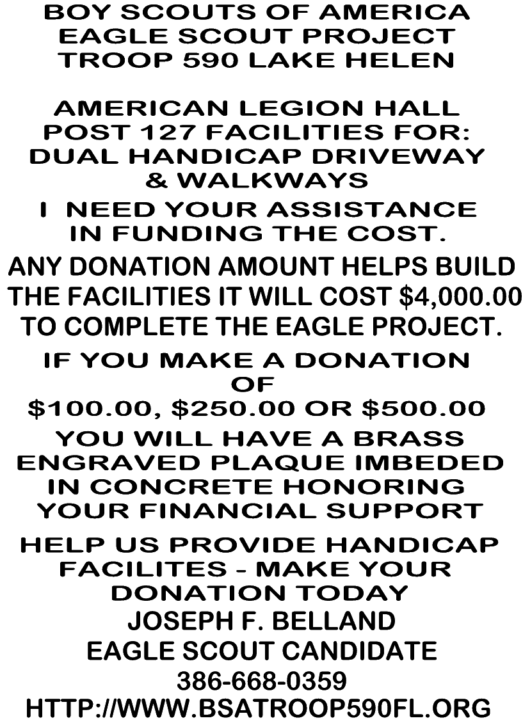

Friday, July 31, 2026

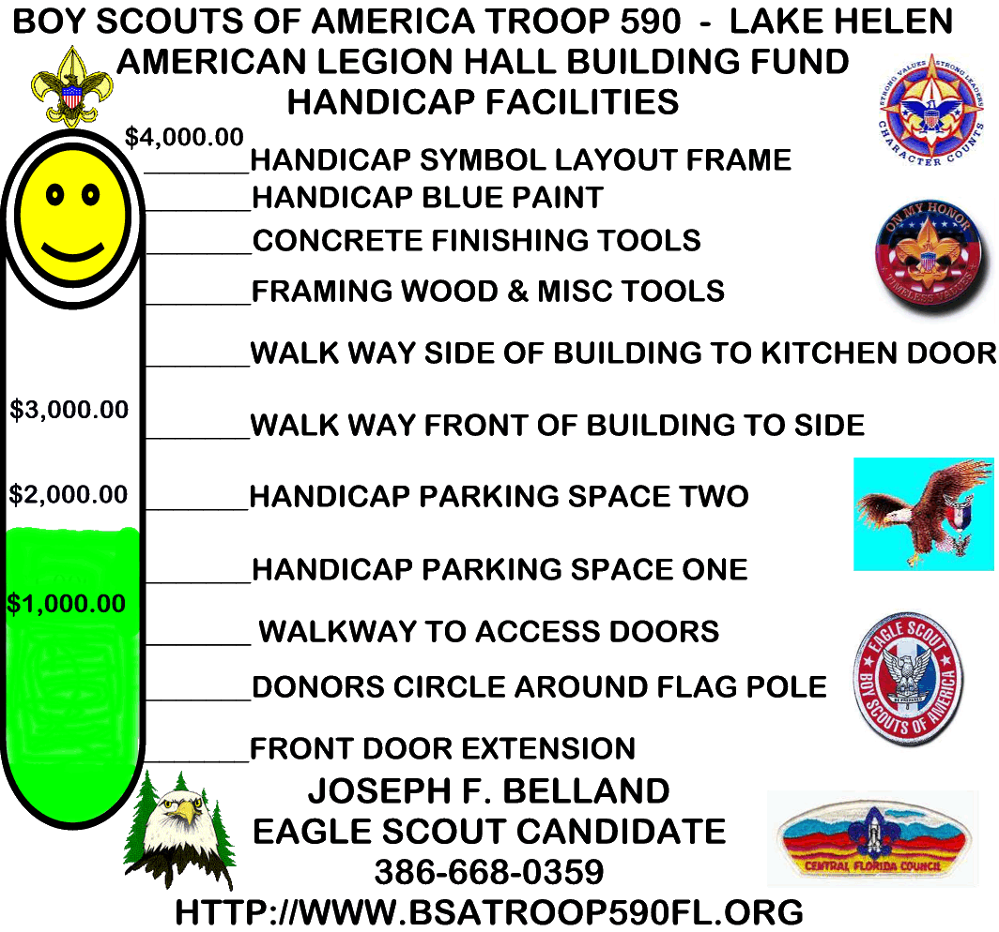

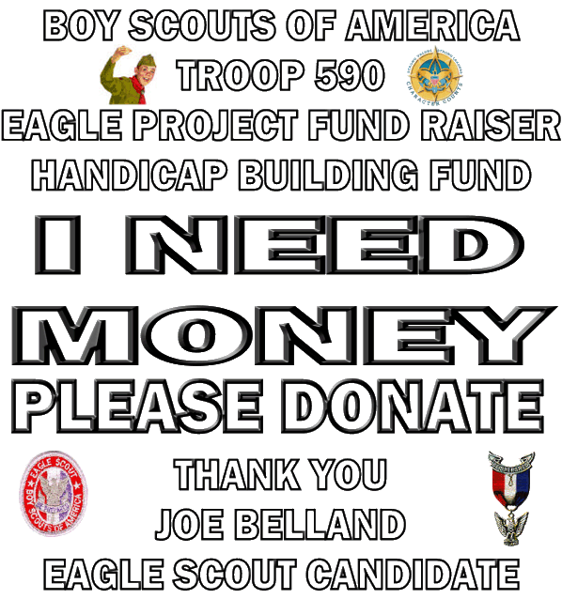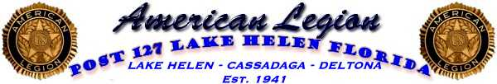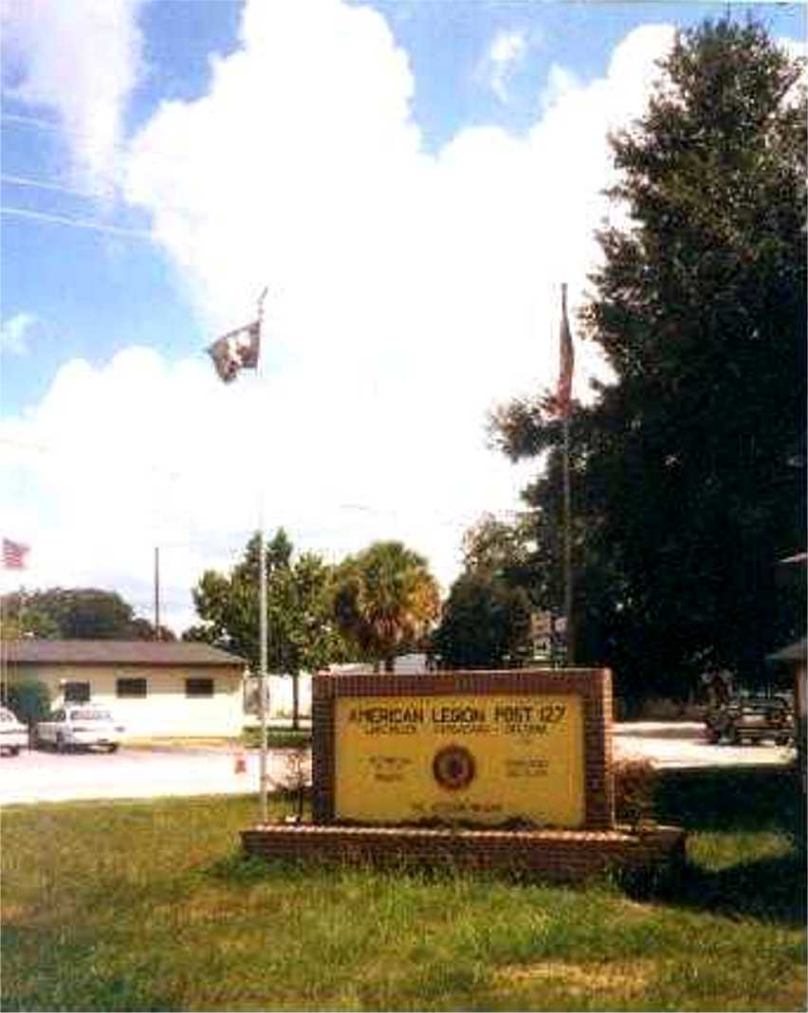

CURRENT PHOTOS OF THE AMERICAN LEGION HALL EXTERNAL CONDITIONS
ESTABLISHED IN 1941.

THE AMERICAN LEGION HALL WAS
BUILT BACK IN 1952 AT 109 CASSADAGA ROAD, LAKE HELEN FLORIDA.

